**CSA PRACTICAL**

**Name – Avinash Gautam**

**Course – B.Sc. (Hons.) Computer Science**

**Exam Roll no. - 20020570009**

**College Roll no. - 20201407**

**SET - 3**

**Outputs :-**

**Hardware modules :-** 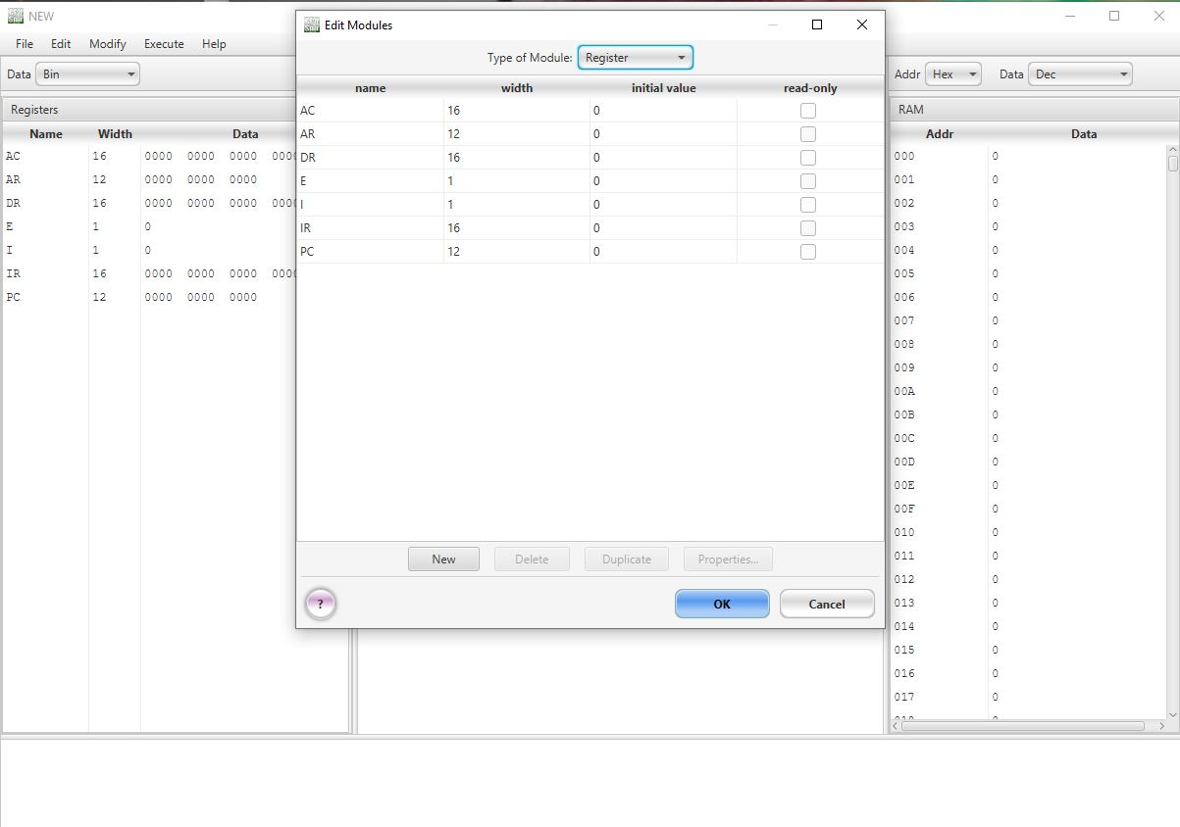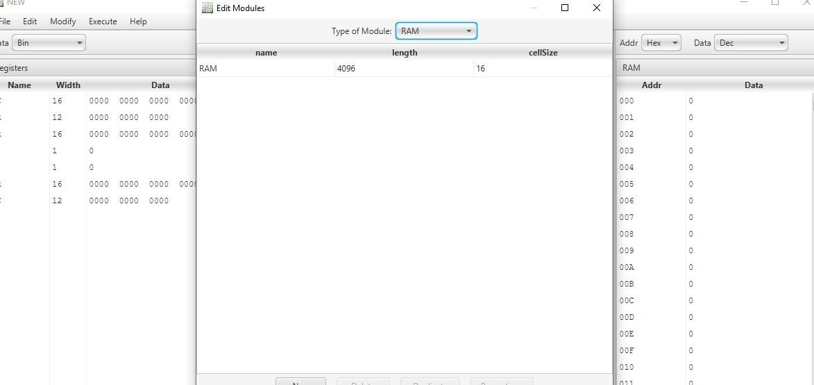

**Fetch routine :-**

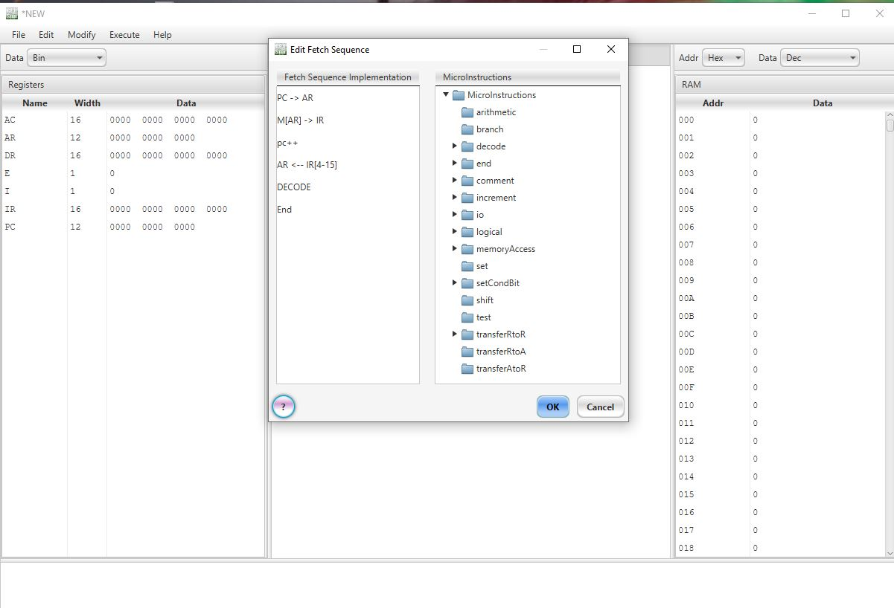

**Machine Instructions : -**

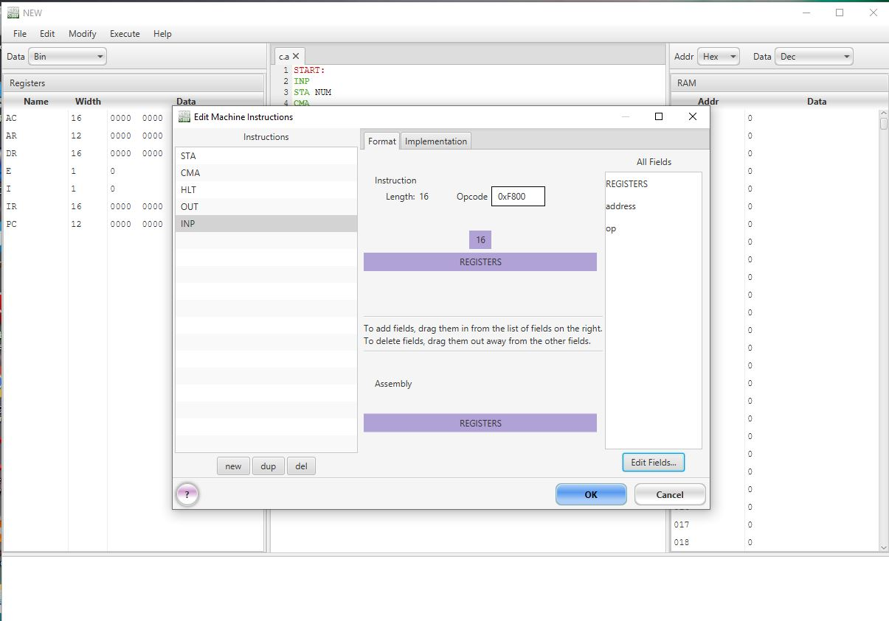

**Perform CMA** :-

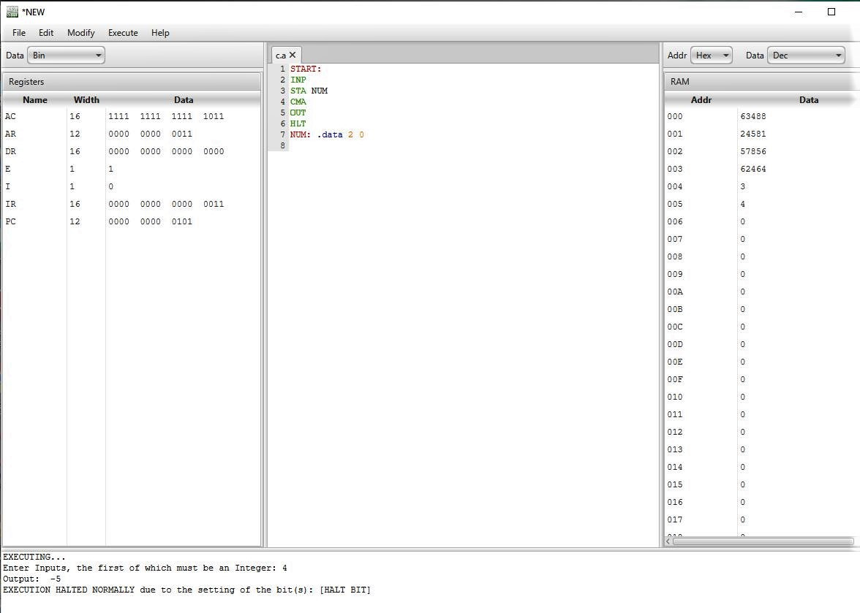

**Description** :- First, create a number of registers and Ram. Then create micro instructions according to what you want to do. Then create a fetch & decode cycle which helps the machine to proceed the instructions one by one. In fetch & decode, we simply assign the instruction address in AR from PC, then read the address of AR and assign in IR and decode IR And IR(4-15) bits have been assigned to AR and increment PC by one so that it can point the next instruction. Then we create the machine instructions according to our purpose. In this we want to complement the entered integer which is saved in AC. So first we create a input instruction , then store this number to RAM by STA, then we perform complement AC and we show the output & at last we design a halt bit to stop the program execution.